Rotary Club of Kathmandu Mid-Town
Breakfast Chatter



17 November 2006 The Weekly Bulletin of Rotary Club of Kathmandu Mid-Town Bc # 20 of 2006-07

District : 3290 Web: www.rotarymidtown.org.np Club Id : 26776

NOVEMBER IS THE ROTARY FOUNDATION MONTH
The Rotary Foundation has two main streams of activity: programs and fundraising. Fundraising directly feeds program activities. The programs of The Rotary Foundation fall into three main categories: Educational Programs, which fund Ambassadorial Scholarships and cultural exchanges; Humanitarian Programs, which fund a wide variety of grant programs to assist people in developing countries; and PolioPlus, Rotary's worldwide effort to eradicate the poliomyelitis virus.

Ms Muna Shrestha talked about waste management as our social responsibility
at the Club meeting on 10 November 2006 .
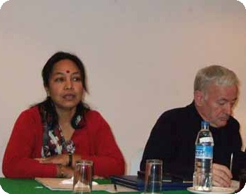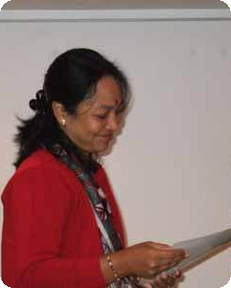
a) Muna Shrestha talking to club members during her presentation, while
Acting President Walter Diller busy in reading through the reading materials provided,
b) Guest speaker Muna Shrestha smiles after receiving a Letter of Appreciation from the acting President.

Weekly Meetings and Programs :
Date | Program/Speaker | Program/Topics of Presentation
17 Nov 2006 | Ananda R Banerjee | Unshackling the farmer by enabling information
24 Nov 2006 | No meeting
25 Nov 2006 | Charter Night | Charter Night Dinner meeting
1 Dec 2006 | Crystal Kaplan | Bhutanese refugees issues

Friday, 17 November :
Mr Ananda R Banerjee will be talking about major constraints faced by the farmers and how information technology help bridge the information gap thereby increasing farm productivity and farmers' incomes, based on experience of Indian rural economy. Mr Banerjee is from Kolkata and currently in Kathmandu, working in Surya Nepal Pvt Ltd, in the capacity of Vice-President – Finance.

Charter Dinner Meeting :
The Mid-Towners will be celebrating their Charter Night on Saturday, 25 Nov 2006.
Venue : Hotel Yak & Yeti
Time : 17:30 hrs

Mid-Towners' team to Hetaura (Cont'd):

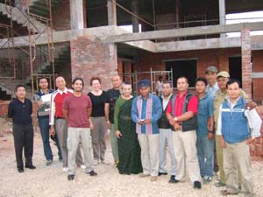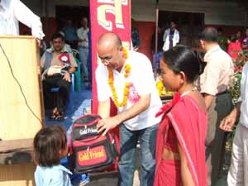
(a) After the tour around Hetauda Community Eye Hospital building under construction
and briefings on the progress of the project, the team posed for a photo
along with Rotarians from RC Hetauda and project officials.
(b) During the School building inauguration program on 9 November Vocational Service Director Govinda Chipalu gave away school bags and other scholarship materials to 41 Chepang students of
Class one of Rastriya Rotary Nimna Maadhyamik Bidhyalaya, Manahari.

Collapse of ecosystems :
Collapse of ecosystems is likely if plunder continues. Humans are living well beyond their ecological means and are now exhausting natural resources at an unprecedented rate.
New calculations on the decline in the planet's capacity to provide food, fibre and timber, and absorb carbon dioxide, suggest we are using 25 percent more resources than are renewed naturally in a year.
Effectively, the earth's regenerative capacity can no longer keep up with demand – people are turning resources into waste faster than nature an turn waste back into resources. Humanity is no longer living off nature's interest, but is drawing down its capital. This growing pressure on ecosystems is causing habitat destruction or degradation and is threatening both biodiversity and human wellbeing.
Source: WWF's bi-annual report
Rotary may play some positive roles on this critical issue.

On Lighter Side : Click at the figure ⇩


The talents and reach of our membership mean that a dollar or a euro or a yen given to the Rotary Foundation can do much more than anyone might expect. When projects are run by knowledgeable volunteers, using volunteer labor and, often, donated materials, a relatively small grant can make a big difference.
RI President William B. Boyd

17 November 2006 The Weekly Bulletin of Rotary Club of Kathmandu Mid-Town Bc # 20 of 2006-07

Editor: RR Shrestha, Club Service Director email: rryes@wlink.com.np

